**GUI Layout**

PicMiner



**2**

Select scan to scan this folder

**4**

Select to browse folders

File 1

File 2

File 3

Select the specific folder to see the contents

Folder 1

Folder 2

Browse

Scan

Folder List

File List

PicMiner

Select to start

**1**

PicMiner

PicMiner

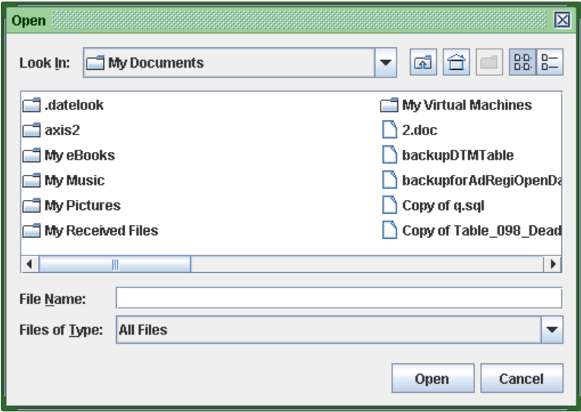

**5**

Select to open the generated HTML document

Open HTML

**Folder Choose : Folder 2**

Repeat 2 and 3 to browse folders and select 4 if you made decision on which folders to scan

**3**

Select a folder you want

Output message to acknowledge user the folder chose

PicMiner